International Advanced Study Course
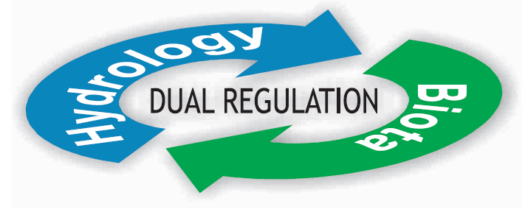
Ecohydrology and Biotechnology for Sustainable Integrated Water Resources Management in HELP
and Ecohydrology Basins

12-22 of September 2010

Poland (Cities: Łódź, Tresta, Poznań)

Application Form
Registration deadline: 15th of August 2009
- General information
Surname:…………………………….……………..……………………….……………………...
Name:…………………………..…….……………………………………………..……………...
Title (Prof/Dr/Mr/Mrs/Ms):…………….…………...........……………………..………………..
Gender (M/F):………………....……...……………….………………………...………………...
Organization:…………………………………………………..…………………...…………..….
Address:……………………………………………………..……………………..….……………
City:…………………………..….……………………………………………..…………………...
Country:………………………………………..……………..…………………………….………
Phone: …………………………………..……………..…………………………….……………..
E-mail:……………………….. …...…………………………………………………………….....
Vegetarian: YES / NO………. …………………………………………………………..………..
- Research experience
………………………………………………………………………………………………………………………………………………………………………………………………………………………………………………………………………………………………………………………………………………………………………………………………………………………………………………………………………………………………………………………………………………………………………………………………………………………………………………………………………………………………………………………………………………………………………………………………………………………………………………………………………………………………………………………………………………………………………………………………………………………………………………………………………………………………………………………………………………………………………………………………………………………………………………………………………………………………………………………………………………………………………………………………………………………………………………………………………………………………………………
3. Transportation
Arrival: date ….……………./time …………....…./town ….………………………………...
Departure: date ….……………./time …………....…./town ….………………………………...
4. Visa
Participants, excluding EU citizens, should check in the Embassy/Consulate nearest to their residence if a Polish Visa is required.
A formal letter of invitation to obtain the visa will be sent upon request. The invitation is not a commitment on the part of the organizers to provide any financial support (only for the administrative purposes). The website of the Ministry of Foreign Affairs of the Republic of Poland indicates countries whose citizens are / are not required to have a visa when entering Poland (http://msz.gov.pl/VISA,REQUIREMENTS,2346.html).

Please send completed application form to secretary e-mails:
agnik@biol.uni.lodz.pl , a.drobniewska@erce.unesco.lodz.pl

