Guidelines for Preparation of Manuscripts for the International Conference on Hydrology and Disaster Management (H&MD 2009) (14 pt)

Kaoru Takara¹, Shuichi Ikebuchi¹ and Kuniyoshi Takeuchi² (11 pt, Times Roman)
¹ Disaster Prevention Research Institute, Kyoto University, Uji, Kyoto 611-0011, Japan (10 pt, Times New Roman)
² International Centre for Water Hazard and Risk Management (ICHARM), Public Works Research Institute (PWRI), Tsukuba 305-8516, Japan

ABSTRACT: The abstract font size is 11 pt. The font is Times Roman, or if not possible, a similar font. There are two single-spaced (11 pt) lines between the paper title and the first author, and a single line between authors. There are two single-spaced (11 pt) lines between the last author affiliation and the abstract. There are two single spaced lines between the abstract and the first section heading.

1 INTRODUCTION

Instructions for the preparation of papers to be presented at the International Conference on Hydrology and Disaster Management (H&MD 2009) are given below. This Microsoft Word document has been prepared in the format that should be used for the preparation of manuscripts.
The manuscripts should be prepared in such a way that are directly suited for photo-offset reproduction. They should be typed or printed in black on A4 size white paper. MS Word or converted PDF is the preferred format. Please save your paper as a Word or PDF file in PC format.

1.1 Overview

The paper must be written in English. The base font is Times Roman, or, if not possible, a similar font. Body text size is 11 pt. There is one single-spaced line between body text and a heading.
New paragraphs in the body text proper start with a about 0.5-cm indentation. Single line spacing is used, and text is evenly justified.

1.2 Page Limit

Papers are limited to six printed pages. Authors should avoid having more than half an empty page for the last page of their paper.

1.3 Section Numbering

Section headings are numbered using the following scheme:

1 LEVEL 1 HEADING (11 pt)
1.1 Level 2 heading (11 pt)
1.1.2 Level 3 heading (11pt)

There should be one single-spaced (11 pt) line between a section heading and the subsequent text.

1.4 Page Setup

The top margin is 3.7 cm, and the left margin is 2.5 cm. The width of the printed text is 16 cm, and the height of the printed text is 23 cm.
Papers must be printed on A4 size paper: 21 × 29.7 cm. Set the margins as shown in Table 1.

2 TABLES

Use 11 pt for Tables (with columns headings bold) and captions (with single line spacing above the table). Table 1 is an example.

Table 1, MS Word margin settings for 8.5 × 11-inch paper.

Margin | Dimension
Top | 3.7 cm
Bottom | 3.0 cm
Left | 2.5 cm
Right | 2.5 cm

3 HEADERS AND FOOTERS

There are no headers, footers, or page numbers. These will be added when publishing the collection of papers

4 EQUATIONS

All equations must be centered and consecutively numbered. Displayed equations should be numbered simply as (1), (2). The numbers should appear at the extreme right of the line in parentheses. For example:

$F=\text{ma}$(1)

Make sure the base font size for the equation is 11 pt. In the text refer to equations as Eq. (1), Eq. (2). There should be one single-spaced line between the equation and the surrounding text.

5 FIGURES

There should be at least one single-spaced (11 pt) line between the figure and the surrounding text. In the body of the manuscript, refer to figures as in the next sentence. Figure 1 is an example. Hydrographs are shown in Fig. 1.

6 REFERENCES

References are to be listed at the end of the paper in alphabetical order of the last names of the first authors and referred in the text by the last name and the year of publication
References are given in the format below. The first line has a 0.5-cm hanging indent.

Chaudhry, M.H. (1993). Open-channel flow. Prentice Hall, Eaglewood Cliffs, N.J. (11 pt)
Graves, A.L., and Gooch, R.S. (1986). "Central Arizona Project start up." Proc. Water Forum '86: World Water Issues in Evolution. ASCE, New York, N.Y., Vol. 1, pp. 546-551.

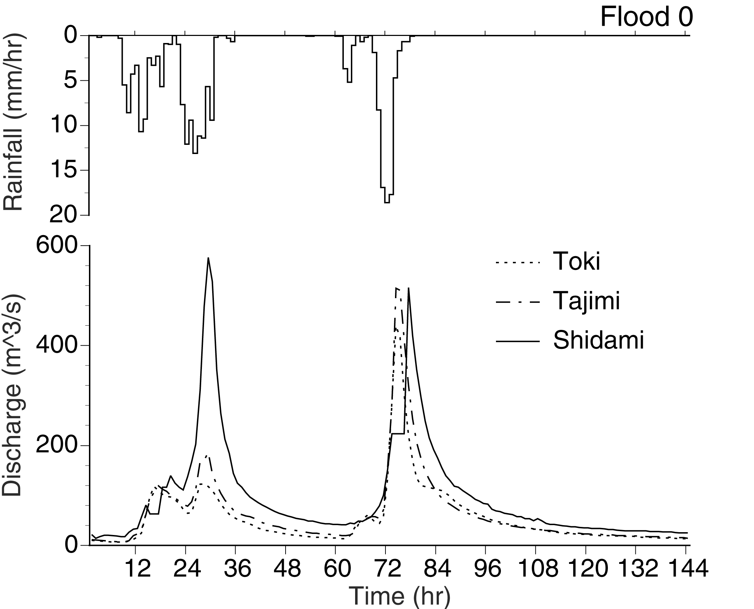
Figure 1, Figure captions are in 11 pt, and not bold.

